**Question 1: Basic Python Concepts (15 minutes)**

**Write a Python script that does the following**:

* + Prints the message: "Welcome to Python Programming!".
  + Declares three variables: an integer, a float, and a string. Assign values to these variables.
  + Displays the data type of each variable using the type() function.
  + Uses a single-line comment to describe each operation.

**Deliverable:**

* + Submit the Python script and a screenshot of the output.

**Ans:** Python Script:-

# Print a welcome message

print("Welcome to Python Programming!")

# Declare three variables: an integer, a float, and a string

integer_variable = 100 # Integer variable

float_variable = 5.18 # Float variable

string_variable = "Hello, Python!" # String variable

# Display the data type of each variable using the type() function

print(type(integer_variable)) # Display the type of the integer variable

print(type(float_variable)) # Display the type of the float variable

print(type(string_variable)) # Display the type of the string variable

**Output:**

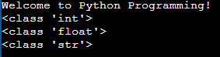

**Question 2: Operators and Expressions (20 minutes)**

**Write a Python script to solve the following problem:**

* + Take two numbers as input from the user.
  + Perform and display the results of the following operations:
    - Addition, Subtraction, Multiplication, Division, and Modulus.
  + Check if the first number is greater than the second and display the result using a relational operator.
  + Use a logical operator to check if both numbers are positive and display the result.

**Deliverable:**

* Submit the Python script and screenshots of input/output.

**Ans:** Python Script:-

# Take two numbers as input from the user

num1 = float(input("Enter the first number: ")) # Convert input to float for possible decimal values

num2 = float(input("Enter the second number: ")) # Convert input to float for possible decimal values

# Perform and display the results of the operations

addition = num1 + num2

subtraction = num1 - num2

multiplication = num1 * num2

division = num1 / num2 if num2 != 0 else "Undefined (division by zero)" # Avoid division by zero

modulus = num1 % num2 if num2 != 0 else "Undefined (modulus by zero)" # Avoid modulus by zero

# Display results of the operations

print(f"Addition: {num1} + {num2} = {addition}")

print(f"Subtraction: {num1} - {num2} = {subtraction}")

print(f"Multiplication: {num1} * {num2} = {multiplication}")

print(f"Division: {num1} / {num2} = {division}")

print(f"Modulus: {num1} % {num2} = {modulus}")

# Check if the first number is greater than the second using a relational operator

is_greater = num1 > num2

print(f"Is the first number greater than the second? {is_greater}")

# Use a logical operator to check if both numbers are positive

are_both_positive = (num1 > 0) and (num2 > 0)

print(f"Are both numbers positive? {are_both_positive}")

**Output:**

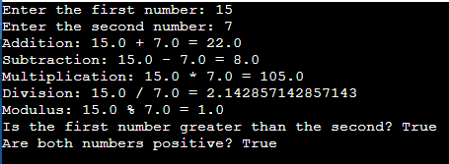

**Question 3: Decision Control Statements (20 minutes)**

**Write a Python program to evaluate a grade:**

* + Take a percentage as input from the user.
  + Determine the grade using the following criteria:
  + A: 90% and above
  + B: 80%-89%
  + C: 70%-79%
  + D: 60%-69%
  + F: Below 60%
  + Use if-elif-else statements to implement the logic.
  + Use indentation properly and ensure the program handles invalid input gracefully.

**Deliverable:**Submit the Python script and screenshots for different inputs.

**Ans:** Python Script:-

# Program to evaluate a grade based on percentage

try:

# Taking input from the user

percentage = float(input("Enter your percentage (0 to 100): "))

# Checking if the input is valid

if 0 <= percentage <= 100:

# Determining the grade using if-elif-else statements

if percentage >= 90:

grade = 'A'

elif percentage >= 80:

grade = 'B'

elif percentage >= 70:

grade = 'C'

elif percentage >= 60:

grade = 'D'

else:

grade = 'F'

# Displaying the grade

print(f"Your grade is: {grade}")

else:

print("Error: Percentage must be between 0 and 100.")

except ValueError:

print("Error: Please enter a valid number for the percentage.")

**Output:**

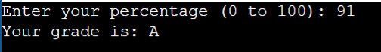

**Question 4: Loop Control Statements (25 minutes)**

**Write a Python script to print a multiplication table:**

* + Take an integer as input from the user.
  + Print the multiplication table for the given number up to 10.
  + Use a while loop to generate the table.
  + Add a feature to break the loop if the user enters a negative number.

**Deliverable:**Submit the Python script and screenshots of outputs for positive and negative inputs.

**Ans:** Python Script:-

# Program to print a multiplication table using a while loop

try:

# Taking an integer input from the user

number = int(input("Enter an integer to print its multiplication table (negative to quit): "))

# Check if the number is negative

if number < 0:

print("Negative number entered. Exiting the program.")

else:

# Initialize the multiplier

multiplier = 1

print(f"\nMultiplication Table for {number}:")

# Using a while loop to generate the table

while multiplier <= 10:

print(f"{number} x {multiplier} = {number * multiplier}")

multiplier += 1

except ValueError:

print("Error: Please enter a valid integer.")

**Output:**

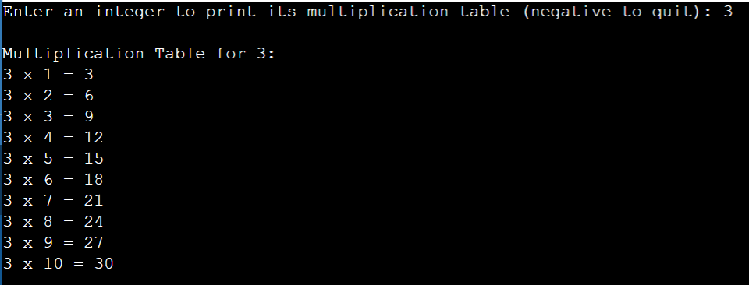

**Question 5: Nested Loops (10 minutes)**

**Write a Python script to display a pattern:**

*

* *

* * *

* * * *

* * * * *

* + Use nested loops to generate the pattern.
  + Include comments explaining the role of each loop.

**Deliverable:**Submit the Python script and a screenshot of the output.

**Ans:** Python Script:-

# Program to display a pattern using nested loops

# Outer loop to control the number of rows

for i in range(1, 6): # Range starts at 1 and goes up to 5 (inclusive)

# Inner loop to control the number of stars in each row

for j in range(i): # Number of stars matches the current row number

print("*", end=" ") # Print a star and stay on the same line

print() # Move to the next line after finishing one row

**Output:**

